NEW Engineers4Humanity website (About Us ))

– Vin’s recommendations for improvement before Going Live

Engineers4Humanity Team behind our success

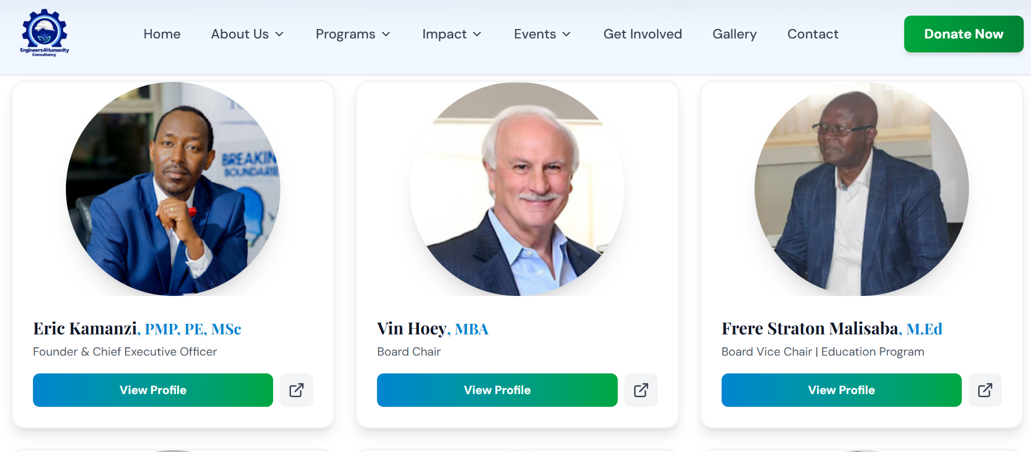
Remove Vin but keep Malisaba and Karegesa
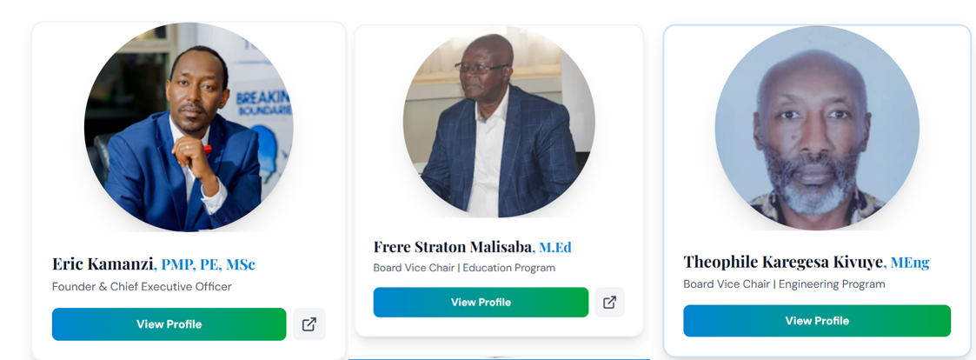

Eric Kamanzi, PMP, PE, MSc
Founder & Chief Executive Officer

Role & Responsibilities
As Founder and Chief Executive Officer, Eric leads Engineers4Humanity's mission to empower refugees and underserved communities through education, engineering solutions, and servant leadership. With over 17 years of humanitarian service, he guides the organization's strategic mission and operations in Rwanda.

Frere Straton Malisaba, M.Ed
Board Vice Chair | Education Program

Role & Responsibilities
Serves as Board Vice Chair overseeing the Education Program in Rwanda, bringing decades of experience in refugee youth education, advocacy, and mentorship. Plays a cornerstone role in sponsoring students and financing vocational training initiatives.

Theophile Karegesa Kivuye, MEng
Board Vice Chair | Engineering Program

Role & Responsibilities
Serves as Board Vice Chair responsible for the Engineering Program, providing technical leadership and strategic direction for all engineering initiatives in Rwanda.

Enock Nkurunziza
Chief of Operations - Rwanda
Role & Responsibilities
Manages operational excellence across all Engineers4Humanity programs in Rwanda, ensuring efficient coordination among teams, effective resource allocation, and successful project implementation.

Emmanuel Sebagisha, M.Ed
Education Program Manager – Rwanda

Role & Responsibilities
Leads the education program initiatives across Rwanda, managing student sponsorships, coordinating with educational institutions, and ensuring quality delivery of educational support to refugee youth.

Octavien Rugirangoga, PE
Engineering Program Manager – Rwanda
Role & Responsibilities
Directs engineering program activities in Rwanda, overseeing Public Health Engineering projects, infrastructure development, and technical capacity building initiatives for underserved communities.

Mukaneza Jacqueline
Finance & Accounting - Rwanda

ALL OKAY

Bernard Ndizeye
Youth Mentorship – Rwanda

ALL OKAY

Jackson Mutega
Youth Mentorship Program - Rwanda
Role & Responsibilities
Provides guidance, support, and mentorship to young refugees, helping them navigate educational pathways, develop career skills, and achieve their full potential through one-on-one coaching and group programs.

Enock Nkurunziza
Education Project Manager – Rwanda

Vin Hoey, Board Chair

Vin Hoey serves as the Engineers4Humanity Board Chair. A senior executive with extensive business and nonprofit leadership experience, he is passionate about serving nonprofits and teaching/mentoring the next generation of leaders. He brings nonprofit board and senior staff experience perspectives to fuel success for causes.

He is Managing Director of Strategic4sight, which provides leading-edge nonprofit strategic planning, marketing, leadership coaching, and governance consulting services. Throughout his career, Vin has provided significant volunteer leadership on the boards of directors of 25 different local, national, and international nonprofit organizations in various cities. He has served as board chair for 10 nonprofits and co-founded four nonprofits. He is committed to serving refugees and vulnerable youth and currently serves on the Leadership Advisory Councils of Heart House and Project Transformation - North Texas in Dallas.

Vin’s servant leadership aligns directly with Engineers4Humanity's mission to restore dignity, expand opportunity, and build pathways to self-reliance for displaced and underserved communities. He supports Engineers4Humanity's ability to build partnerships and mobilize resources for refugee self-reliance, job creation, and vocational training programs in Rwanda.

His long career at ExxonMobil included serving as Global Marketing Communications Manager for ExxonMobil Chemical and earlier leading Corporate & Marketing Communications across Europe, Africa, and the Middle East from Brussels. He found, late in life, that he loves teaching and has taught the Nonprofit Marketing Strategies course at the SMU Cox Graduate School of Business in Dallas, and undergraduate courses at SMU and DePauw University in Indiana.

As Board Chair of Engineers4Humanity, Vin plays a pivotal role in developing strategic partnerships, donor engagement, and helping programs across Rwanda. His leadership strengthens board governance and supports the organization's mission.

